Bus Driver Information

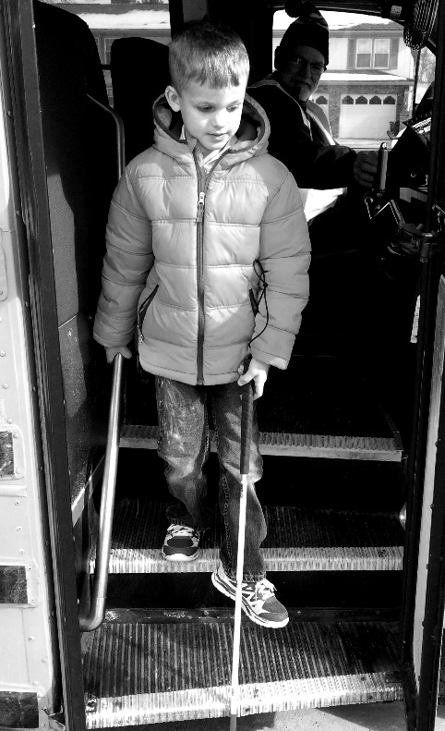
This year, ________________________________________________________ (Student ID #___________________) will be riding your bus. He/She has been identified as a student with a visual impairment by the OPS Vision Department and will require special consideration during transport. The following information should be shared with any bus-assigned paraprofessional and/or substitute bus drivers.
Those students able to transfer independently (see below) should be employing proper cane technique as demonstrated by the picture at right. Cane should be in front to detect stairs and opposite hand should be on the hand rail.

Those students requiring sighted guide technique will hold onto your pinkie finger, wrist or elbow depending on their age/size. You will simply guide them (see techniques on reverse side) to their location on the bus. IF CARS ARE PRESENT AND/OR SAFETY IS A CONCERN (a very young student or a student who runs/ wanders), then hold hand as with other similar students. When in doubt, opt for safety and refer questions to the Orientation and Mobility Specialist (contact information below).

STUDENT NEEDS (AT A MINIMUM):
- Student requires direct adult intervention to personally lead the student to the designated location and to ensure safety throughout the transport.
  - Sighted Guide technique should be used with the student
  - Student should secure cane and/or alternative mobility device (AMD) with him/her
  - Responsible adult should remain in constant contact with the student throughout transitions on the bus
  - _____________________________________________________________________________________________

- Student requires direct supervision by an adult, but can independently complete needed transitions. Responsible adult should ensure safety throughout transition.
  - Sighted Guide technique should be used with the student
  - Student should secure cane with him/her
  - _____________________________________________________________________________________________

Any questions or concerns can be addressed to the Orientation and Mobility Specialist, _________________________________________________________________, at __________________________________
BASIC SIGHTED GUIDE TECHNIQUE

- Make contact. Introduce yourself both verbally and by touching your hand to the student’s. Explain that you will be the student’s guide and he/she is to proceed with you.

- Grip. The student will take hold of your arm just above your elbow*. Their grip should be firm. If working with a younger student, offer your pinkie, hand or wrist as this height will be more appropriate for the student. | 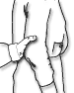
- Stance. Keep your arm relaxed. The student should stand beside you, about a half pace behind. REMEMBER: When guiding a student, you occupy a wider space than you are used to and it is YOUR responsibility to lead the student around any obstacles. | 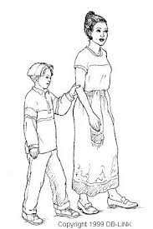

Any questions or concerns can be addressed to the Orientation and Mobility Specialist, _______________________________________________, at _______________________________

