Instructions on adding Alt Text
Creating Accessible Materials Workshop
By Diane Brauner

Alt Tags (alternative text) is a word, phrase or sentences that can be associated with an image (read by a screen reader) or inserted before a picture to explain the image. Since screen readers do not describe images (or do not capture the correct educational information when using auto-generated descriptions), alt tags are used to describe the meaning or content of the picture. The information that is gleaned visually from an image should be described in text format for students who are visually impaired.
When creating Alt Tag Descriptions
- Context is Key
- Consider Your Audience
- Be Concise
- Be Objective
- General to Specific
- Tone and Language
Insert images as “in line” not wrap around text.

Alt Text descriptions vs. Captions
- Alt Text descriptions are read by a screen reader but are visually hidden; these descriptions do not appear as printed text above the image. Alt Text descriptions are only available to viewers using screen readers. In some applications, there is a limited amount of characters that can be used in the Alt Text format.
- Captions can also be used to provide a description of the image; captions do visually appear as text above (or below) the photo. Captions are used to provide information to viewers who rely on vision and viewers who rely on screen readers. Captions can be longer/more detailed than the Alt Text format. Often educational images – diagrams, charts and other complex images – often need longer descriptions.

Teacher Note: If the description is beneficial for everyone – including low vision students who are not using a screen reader - then insert a caption to describe the image.

Example
The image below has both a Caption (Figure 1) and an Alt Text (visually hidden but verbalized by a screen reader). For demonstrations purposes, the Alt Text description describes the purpose of the image as it is used in this document while the Caption describes the actual image. The hidden Alt Text is: “Example of a diagram Alt Text label; label starts with the General information and then Specific information.”

Figure 1: A web diagram has a center circle and five smaller circles connected to it. The center circle is labeled Scientific Methods. One connected circle is labeled Observation. The other four circles are labeled A, B, C, and D.
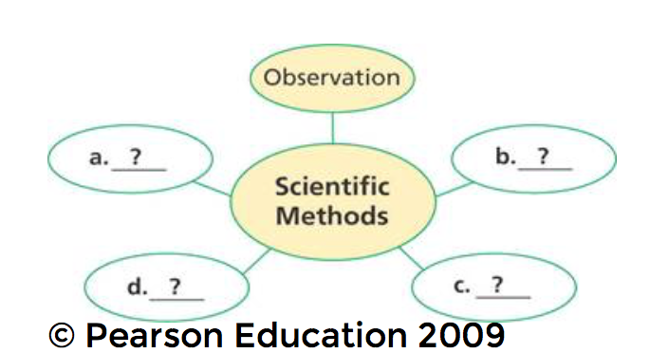

To add a picture to a Word document using a Mac Computer
Hint: Save the picture on your desktop for easy access. Photos are typically assigned a number. Be sure to re-name the picture to easily locate the picture, especially if the picture is shared with a person that uses a screen reader.
- Place the cursor in the desired location within the Word document.
- In the Ribbon, select Picture > select the current location of the picture > select the name of the desired picture > select Insert.

To add a Caption to a Word document using a Mac Computer
- Place your cursor on the picture that is now embedded in the Word document.
- Right Click (hold Control key and click on the mouse pad).
- Select Insert Caption from the popup menu.
- Type in the desired description.

The caption will appear as smaller, blue text above the image. Captions start with Figure 1 and additional captions will be sequentially numbered.

To add Alt Text to a Word document using a Mac Computer
- Place your cursor on the picture that is now embedded in the Word document.
- Right click (Hold Control key and click on the mouse pad).
- In popup menu, select Format Picture from the popup menu.
- In Window, select Layout and Properties (third icon).
- Select Alt Text.
- For complex images, such as a chart, type in the title. (Example: Supply and Demand Chart). For simple images, such as a photo of a grizzly bear, type in a description of the bear. (Example: Photo of a mother Grizzly bear and two young cubs walking through a meadow.)

Teacher Note: Carefully read any questions that are related to the picture. The alt tag description must include any test information that is only provided visually!

To Add a Caption to a Word Document using a PC
- Select or Click on the desired picture within the Word document.
- Click on References > Insert Caption

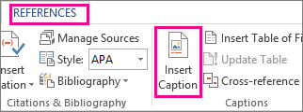

- Use the default label (Figure), type your caption in the Caption box > select OK.

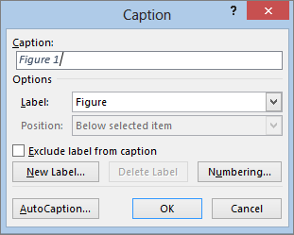

OR

- Right click on the image to open the context menu
- Select Insert Caption
- Follow step #3 above.

To Add Alt Tag to a Word Document using a PC
- Right click on the desired image.
- Right click to open the context menu.
- In the popup menu, select Format Picture.
- Select the Home tab (located in the top left).
- In the Format Picture pane on the right side of the screen, select Lay out and Properties (third icon)
- Select Alt Text.
- In the Title textbox, type in the title of the image, if appropriate.
- In the Description textbox, type in the alt tag description of the image.

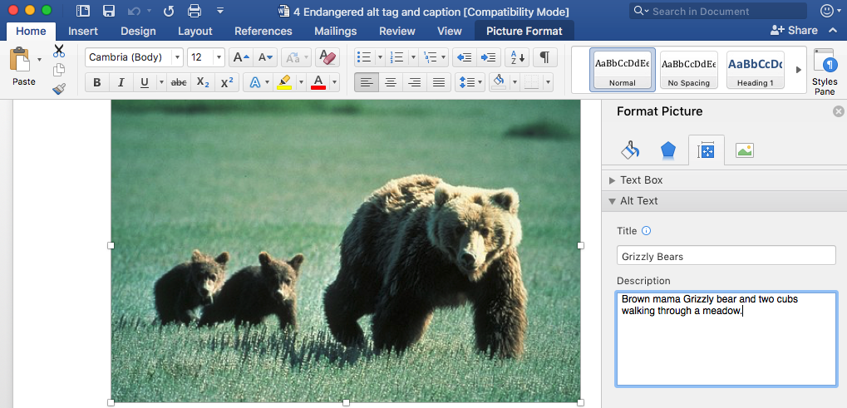

Note: The screenshots were taken using Word on a Mac computer; instructions were also confirmed on a Mac computer. Microsoft Word is available for both Apple Computers and PCs; the instructions and screenshots should hold true for a PC.

For detailed Alt Text information, go to the Creating Image Descriptions (Alt Text) post on the Paths to Technology website.

