4 Endangered US Mammals

A plant or animal species that exists in such small numbers that it is in danger of becoming extinct. One of the main factors that put these species at risk is the destruction or pollution of its native habitat.

Grizzly Bears reach weights of 400 – 1,5000 pounds; the male is on average 1.8 times as heavy as the female. The coloring ranges widely across geographic areas, from blond to deep brown or black. The grizzly has a large hump over the shoulders which is a muscle mass used to power the forelimbs in digging. In spite of their massive size, these bears can run at speeds of up to 35 miles per hour.

Location:
Grizzly bears live in continental US (lower 48 States), predominately in Idaho, Montana, Washington, and Wyoming.

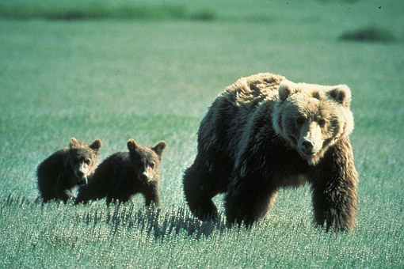

The black-footed ferret is well adapted to its prairie environment with its color and markings blending in with the grassland soils and plants. It is a slender, wiry animal, enabling them to easily move through prairie dog burrows. The black-footed ferret has a black face mask, black feet, and a black-tipped tail and their sleek body is a yellow-buff color. It has short legs with large front paws and claws developed for digging. The black-footed ferret is 18 – 24 inches long including a 5-6 inch tail and weighs only one-and-a-half to two-and-a-half pounds. These ferrets primarily eat prairie dogs.

Location:
The black-footed ferret lives in Arizona, Kansas, Montana, New Mexico, South Dakota, and Wyoming.
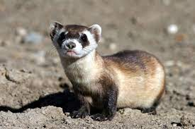

The Jaguar, a large, heavy bodied big-headed cat, is the largest cat species in the Americas and third-largest cat in the world. Jaguars often live near water and are good swimmers. Yellowish to tawny, spotted with black rings in horizontal rows along the back and sides; most rings are tan inside with one or two black spots.
Location:
The Jaguar lives in Arizona and New Mexico.

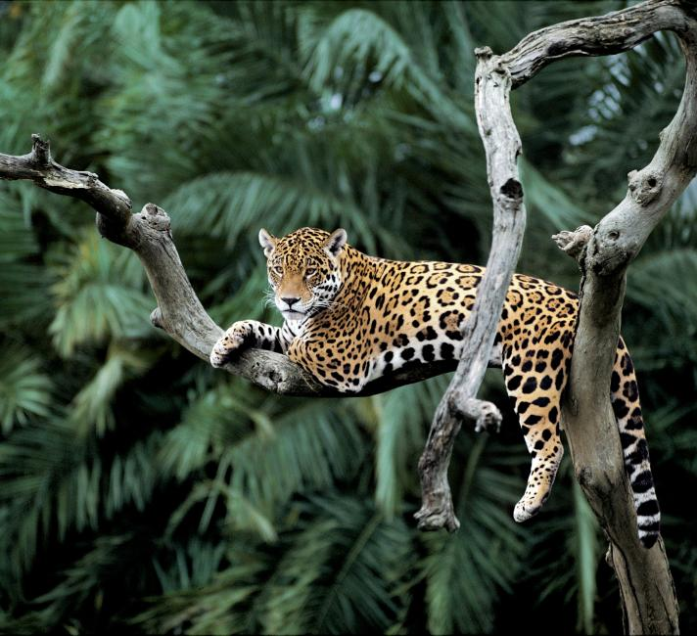

The Florida Panther is a large, long-tailed cat with a great deal of color variation: silver-grey, tawny, reddish brown and black. Males measure nearly 7 feet from nose to tip of tail and females about 6 feet. They have more in common with the house cat than a lion or tiger. Unlike other large cats, they are unable to roar. The Florida Panther is the official state mammal of Florida.

Location:
The Florida Panther lives in Florida.

