CodesSnaps - Psyched for STEAM Short Course Outline
Schedule
Time | Activity | Type | Leader(s)
12:35 – 12:50 | Introduction | Talk | Tim
12:50 – 1:20 | Getting to know SPRK+ | Team Activity | Team Mentors
1:20 – 1:50 | Extend Your Knowledge | Team Activity | Team Mentors
1:50 – 2:00 | Break & City Setup
2:00 – 2:50 | City Challenge | Team Activity | Team Mentors
2:50 – 3:00 | Wrap-Up | Group Discussion | Tim

Details
Part 1. Introduction

Content | Logistics
- Introduction  - Purpose  - Introduce Mentors  - Sphero SPRK+ Overview  - How it works  - Accuracy (First team activity will demo this)  - CodeSnaps Overview  - Commands used for coding  - Look through Command Box, point out:  - Left/Right Turn has two types  - Repeat has End Repeat  - Set Color To & Spin  - Places for numbers (numbers on team table)  - Activity Overview  - Getting to know Sphero SPRK+ – basic movements  - Extending your knowledge – obstacle course  - City Challenge – use what you’ve learned to navigate a city  - Mentors Role  - Explain objective  - Answer questions  - Scan Code  - Orient SPRK+  - Narrate SPRK+ movements on course | - All gather around the big table  - Pull up chairs  - Teams stay together  - Materials/Equipment  - Sphero for each team (3)  - CodeSnaps Command box (3)

Part 2. Getting to know SPHERO SPRK+

Content | Logistics
- CodeSnaps Review  - Mentor:  - addresses any question from intro  - demo attaching numbers  - First activity - Test accuracy by running 1 meter  - Mentor: explains objective  - Discussion: Lessons learned  - Mentor explains that later activities will be affected by the SPRK+’s accuracy factor. You will probably need to allow for this when determining how far to go before turning a corner.  - Second activity - Make 1-meter square  - Mentor: explains objective  - Make SPRK+ travel in a 1-meter square  - Discussion: Lessons learned  TIME CHECK – What time is it? Is there time to run the Bonus Activity and be done by 1:20 (+- 5 minutes). If not, do not run the Bonus Activity.  - Bonus activity (time allows) - Loop to make 1-meter square  - Mentor: explains objective  - Shorten the code to make SPRK+ travel in a 1-meter square  - Let students explore command box and see what could work  - Discussion: Lessons learned | - Each team gathers in their team spot to start  - Materials/Equipment  - SPRK+  - CodeSnaps Box  - 1-meter stick  For each activity:  NOTE: No special setup is needed. The teams sharing the big table will each work on one side of the center dividing noodle.  - Mentor: explains objective  - Students: write code  - Mentor:  - Scans and reads back code – students check code  - Gets SPRK+ from charging station  - Orients SPRK+  - Runs code  - Narrates SPRK+ movements  - Students: Assess results  - If changes to the code are needed, start back at Step 2  - Mentor: Put SPRK+ back in charging station

MENTORS: Prior to starting Part 3, lay out Obstacle Course using Diagram 3.1 on the SPRK+ table.

Part 3. Extend Your Knowledge

Content | Logistics
- First activity – Run an Obstacle course with 1 obstacle  - Mentor: explains objective  - There is an obstacle course on the table.  - SPRK+ is sitting at the Start position, facing forward.  - The finish position is marked with four small metal cups with bells inside.  - There is one obstacle on the course that you must go around.  - You have a meter stick and CodeSnaps box.  - Your objective is to move SPRK+ around the obstacle and get to the finish line.  - Discussion: Lessons learned  TIME CHECK – What time is it? Is there time to run the Second Activity and be done by 1:50? If not, do not run the Second Activity. If there is a little time, consider changing the Finish position on the first course and having the students run that.  xx  MENTORS – Change the Course to match Diagram 3.2, either 3.2 Option 1 or 3.2 Option 2  xx  - Second activity - Run another obstacle course.  - Mentor: explains objective  - There is an obstacle course on the table.  - SPRK+ is sitting at the Start position.  - The finish position is marked with four small metal cups with bells inside.  - There are one/two obstacles on the course.  - You have a meter stick and CodeSnaps box.  - Your objective is to move SPRK+ around the obstacles and get to the finish line.  - Discussion: Lessons learned  TIME CHECK – What time is it? Is there time to run the Bonus Activity and be done by 1:50? If not, do not run the Bonus Activity.  xx  MENTORS – Switch the Start and Finish positions of the 3.2 course  xx  - Bonus activity - Run an Obstacle course with 2 obstacles  - Mentor: explains objective  - The obstacles are still in the same places but the Start and Finish have been moved.  - Discussion: Lessons learned | - Each team gathers at their SPRK+ table and stands at the front edge.  - Materials/Equipment  - SPRK+  - CodeSnaps Box  - 1-meter stick  For each activity:  NOTE: Special setup is needed. See diagrams 3.1 and 3.2  - Mentor: explains objective  - Students: write code  - Mentor:  - Scans and reads back code – students check code  - Gets SPRK+ from charging station  - Orients SPRK+  - Runs code  - Narrates SPRK+ movements  - Students: Assess results  - If changes to the code are needed, start back at Step 2  - Mentor: Put SPRK+ back in charging station

VERY IMPORTANT: Return SPRK+ to a charging station before going on break.
During the break, the two tables will be set up with a City layout. Each team will also get a Graphics Board which has a scale layout of the City they will use. Two teams will share the large city. One team will use the small city.

Part 4. City Challenge

Content | Logistics
- Preparation – Understand the scale layout  - Mentor: explains layout  - Legend/Buildings  - “No driving zones” marked by bells in city  - Scale  - Students: familiarize themselves with layout  - Determine distance between two buildings  When students are ready, proceed to the first scenario.  xx  - Activities  - Run through as many scenarios as time permits.  - If students finish all the pre-planned scenarios, they can develop their own.  TIME CHECK – Plan to finish by 2:45 so students can be gathered around the table by 2:50 for the Wrap-Up.  xx | - Each team gathers at their team table.  - Materials/Equipment  - SPRK+  - CodeSnaps Box  - 1Graphics Board with City Layout  - Scenario Sheet for each team member  For each activity:  NOTE: The tables each have a city layout.  - Students:  - read scenario  - write code  - Mentor:  - Scans and reads back code – students check code  - Gets SPRK+ from charging station  - Orients SPRK+  - Runs code  - Narrates SPRK+ movements  - Students: Assess results  - If changes to the code are needed, go back to Step 1  - Mentor: Put SPRK+ back in charging station

Part 5. Wrap-Up

Content | Logistics
TBD  xx | - All gather around the big table  - Pull up chairs

Diagram 3.1

Note: Two teams are sharing the big table for this exercise. The dividing noodle is in place, giving each team a 5’ x 5’ area. The third team has the smaller table all to themselves.

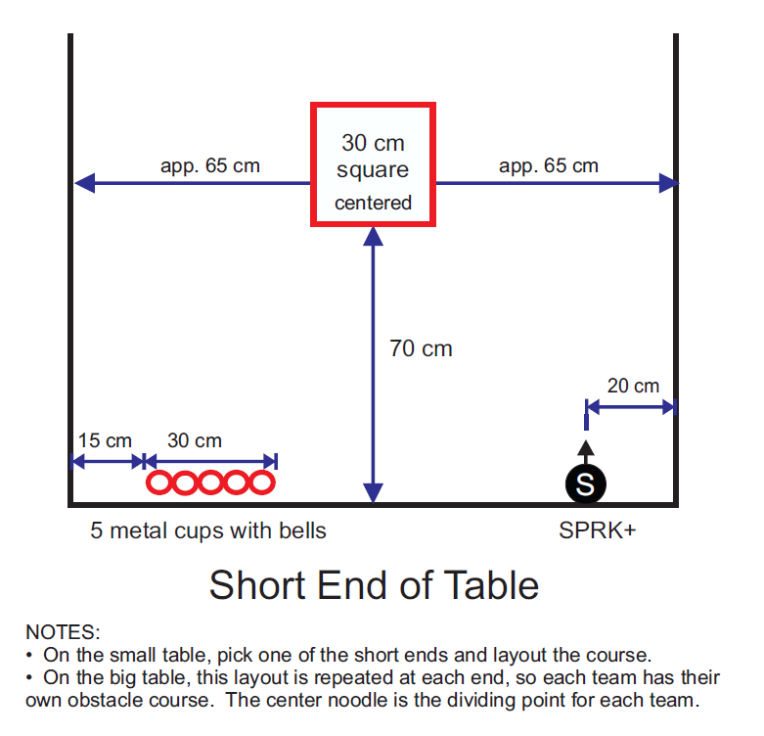

Diagram 3.2 Option 1

Note: Two teams are sharing the big table for this exercise. The dividing noodle is in place, giving each team a 5’ x 5’ area. The third team has the smaller table all to themselves.

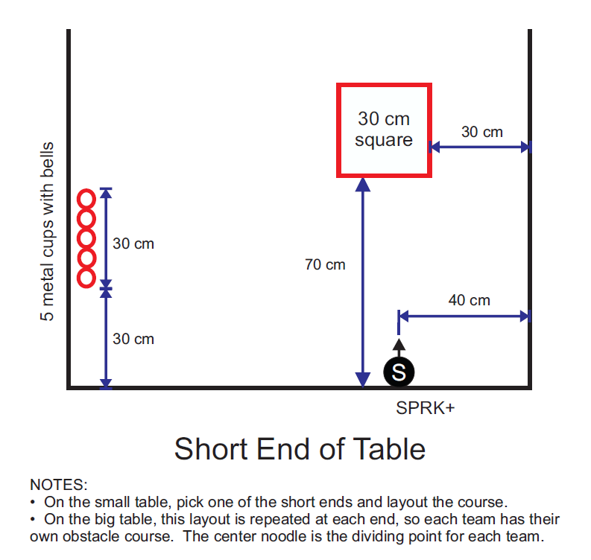
Diagram 3.2 Option 2

Note: Two teams are sharing the big table for this exercise. The dividing noodle is in place, giving each team a 5’ x 5’ area. The third team has the smaller table all to themselves.

